Dear Year 3 Teachers, April 2021

I hope you are all keeping well in these challenging times.

Last summer your children missed out on taking part in our annual Mini Games Competition, when they were in year 2, and I am mindful that they did not get the opportunity to compete with other children last year. I am hoping, with your help, that we can get as many children as possible participating in a Fitness Threes Virtual Event. We hope 100% of schools will participate.

We would like all year 3 children to compete on their school sites, at some point, this term. The timings are up to you, to fit in with your school plans. Our intent is simply to make sure the children have fun, move their bodies, and are rewarded for their efforts. You can deliver the events in your PE lessons and collect the results over a few weeks, or you could have an afternoon of Fitness Threes and make it a little more special, possibly in National School Sport Week (19th – 25th June), or during your sports day week. It is totally up to you.

Thank you in advance to all of you that will give it a go, as we know how much organisation goes into these events. If you are taking part, please email me/get your PE coordinator to email and let me know the number of children attending, (no names are needed just numbers please), so we know how many certificates/rewards to deliver.

We have everything you need in the documents below to run the competition. Here is the link to the video to show you what to do. https://youtu.be/_OzKlkhWtH0 We have used equipment that you should have in school and we have kept the activities simple and achievable for all.

We shall also deliver some sporting value stickers for you to give out to selected children who have done well and showed the values of honesty, determination, self-belief, teamwork, respect, or passion. It is our continued aim to “Reframe Competition” as having a place for everyone, and to celebrate the sporting values as we compete.

There is a Poetry Competition attached, for the children to write about the sports and PE that they enjoy and for you to send us your top 2 0r 3. Prizes for the winning entries.

If you need any clarification on the activities, have any questions, or would like any help in running the activities, then please get in touch.

Thank you for your support and we are looking forward to seeing pictures, videos and hearing how it went.

Yours sincerely

Samantha Patching
School Games Organiser for North West Essex SSP

Virtual Fitness Threes Competition
Video Link : https://youtu.be/_OzKlkhWtH0
Jumps Station
Instructions:
Mark out cones at 1m intervals from a start line.
Each athlete stands at the start line, they then perform 3 standing two footed jumps in a row to see how far they can travel. Their score is the nearest cone they have reached.
In the example below the athlete has score 5 points
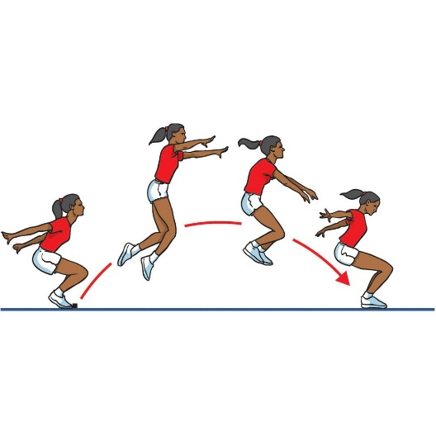
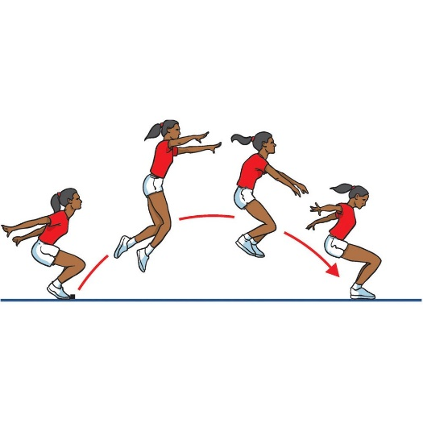
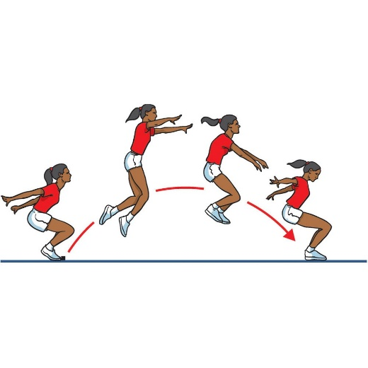

They can have three attempts and measure their best distance.

Distance Converter

Distance | Points
Up to 2m | 2 points
Up to 3m | 4 points
Up to 4m | 6 points
Up to 5m | 8 points
Over 5m | 10points

Virtual Fitness Threes Competition

Seated Chest Push Station
Instructions:
From a seated position the athlete gets to take three chest pushes. Each chest push is measured to the nearest meter and the distance is added together.
The athlete may lean back at the start of their push action, but the ball must remain in front of their chest and cannot come from over their head.

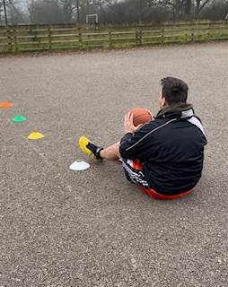

Score by counting the cone you are nearest to when the ball bounces. Add up the total of all three throws:
e.g. Cone 4 + Cone 4 + Cone 5 = Total 13m

Virtual Fitness Threes Competition

Speed Bounce Station
Instructions:
Each athlete has 20 seconds to bounce as many times as possible from side to side over the barrier. As most schools do not have a speed bounce mat, we suggest a line of cones to work as the barrier.
A jump only counts if it is a two foot to two foot jump.
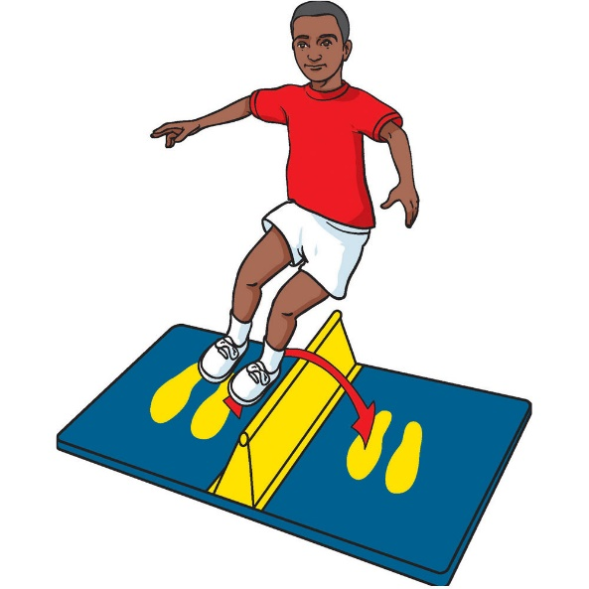

Number Converter

No. of Jumps | Points
Up to 10 | 2 points
Up to 20 | 4 points
Up to 25 | 6 points
Up to 30 | 8 points
30 + | 10points

Virtual Fitness Threes Competition

Agility Station
Instructions:
Each athlete must complete agility course as many times as possible in 45 seconds. Starting on the centre spot they must run out to the first pile of cones and collect one and return it to the centre spot, then carry onto the other stack of cones and back again. The number of cones in the middle is the athlete’s score.

The distance between centre cone and each point is 5metres.

10 Cones
10 Cones

Score is the numbers of cones collected.

Virtual Fitness Threes Competition

Stamina Station
Instructions:
Each athlete must complete as many shuttles of a 20m course as they can in 2mins.
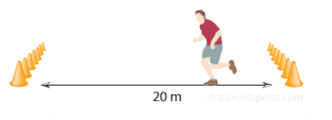

Their score is how many completed lengths they managed in the time limit.

Virtual Fitness Threes
Scorecard
Name School
Event | Time/Distance | Score
Seated Chest Push | Total of 3 throws  + + + =
Standing Long Jump | Which cone you are nearest to ?
Stamina | How many laps?
Agility | How many cones?
Speed Bounce | Convert into points?
TOTAL

Virtual Fitness Threes
Scorecard
Name School
Event | Time/Distance | Score
Seated Chest Push | Total of 3 throws  + + + =
Standing Long Jump | Which cone you are nearest to ?
Stamina | How many laps?
Agility | How many cones?
Speed Bounce | Convert into points?
TOTAL

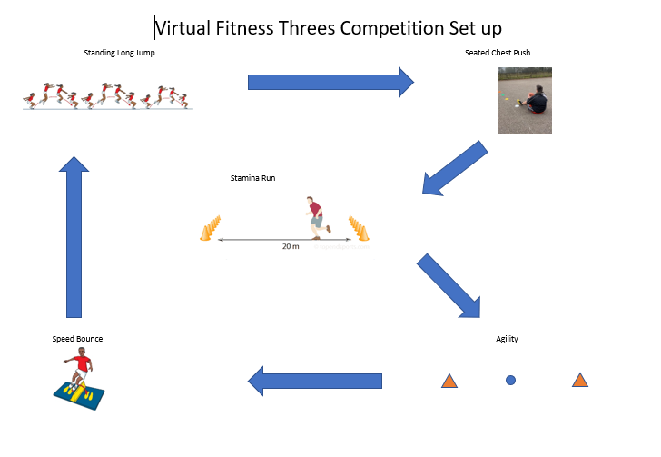

Once all the children have their score sheets completed, please email me at spatching@ramseyacademy.com and I will come and collect and drop off certificates and rewards.

Fitness Threes Sporting Poems Competition
It goes without saying that PE is fun, moving our bodies and enjoying the run,
So can you compose a poem about sport, things you enjoy, just give it a thought.
Send them to me by email or post, there’s Prizes for the ones we enjoy the most.

As a class choose 2 or 3 poems that you like the most. Send them to me as a video or written copy, to spatching@ramseyacademy.com .Include Names and School details.
Closing Date June 25th. Prizes for the overall winning Poems.

