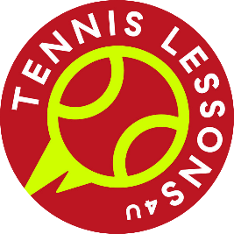
Class: _________________
Name: _________________
Tennislessons4u virtual tennis event
Score Sheet

EVENT | YOUR SCORE
- Figure of 8
- How many Claps?
- Keepie Uppies
- Bucket Ball
- Rally

REMEMBER: Every point counts!

