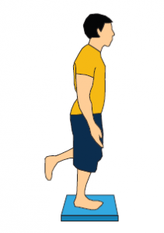
Activity 1: Balancer
A balancer develops a sense of balance and stability on both sides of the body - essential skills in the world of sport.
‘How long can you stand in one position like a statue?’
- The balancer stands on one foot (you can use a partner initially to gain balance).
- The stopwatch must start from when the child is standing on one foot or when the child lets go of the partners arms. The stopwatch will stop when the foot that has been lifted touches the floor.
- Aim for 10 seconds (reception), 15 seconds (year 1) and 20 seconds (year 2).
- Record your maximum time on the results table.
Challenge. Try these…
Try balancing on the other leg
Balance with your eyes closed
Balance without use of arms
Hold your leg whilst balancing
Hold your ears whilst balancing
Make a funny shape whilst balancing
Top Tips
Balancer is relaxed and stable
The arms and hips help the balance
The focus is forwards rather than down

Activity 2: Bouncer
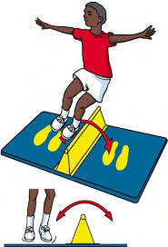
A bouncer develops core stability, balance, agility, and rhythm. These vital skills will improve the child leg speed and ability to accelerate.
‘Can you jump like a kangaroo?’
- Place something flat on the floor that you could jump over e.g., a rolled-up towel
- The bouncer must jump with two feet side to side over the line.
- The bouncer has 20 seconds to complete as many bounces as they can in 20 seconds.
- Aim for 10 jumps (reception), 15 jumps (year 1) and 20 jumps (year 2).
Challenge
Jump over an object instead of something flat
Make a jumping assault course – jump forwards and back as well as side to side
Top Tips
Smooth bouncing
Focus on a forward point
Arms help to balance
Start carefully and build rhythm

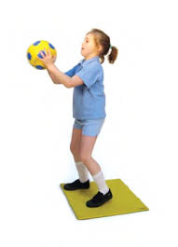
Activity 3 – Catcher
Catcher is a challenge which improves hand eye coordination – an ideal skill for any ball game.
‘Can you throw a ball up in the air then clap 3 times before you catch it again?’
For every one of the 4 throws that you complete, you will get 1 point. Aim for 2 points (reception), 3 points (year 1) and 4 points (year 2)
- Throw a ball up in the air and catch it
- Throw a ball up in the air, clap once, then catch it again before it touches the floor
- Throw a ball up in the air, clap twice, then catch it again before it touches the floor
- Throw a ball up in the air, clap three times, then catch it again before it touches the floor
Challenge
Use a smaller ball that will be harder to catch
Try bouncing the ball between claps instead of throwing
Add more claps
Try touching your head or the floor before catching
Top Tips
Make sure you the ball high enough
Throw the ball smoothly and gently

Activity 4 – Thrower
The thrower develops stability, control, and body power – an integral component of many team games. Although this activity can be performed indoors, you may want to go outside.
‘How far can you throw?’
- The thrower must stand behind a marker (you could use your teddy to make a marker). Standing next to your marker, hold the ball with both hands at chest level
- Push the ball upwards and outwards as far as possible
- Measure how far in metres you throw the ball (this can just be big grown-up steps). Make sure you only measure to where the ball touches the floor first and not where it rolled to.
- You have three throws and the furthest one is your score for this activity.
- Aim for 4 metres (reception), 5 metres (year 1), 6 metres (year 2).
Challenge
Working with a partner – what is your longest caught chest pass?
How many chest passes can you catch at 5 metres without dropping the ball?
Explore other ways of throwing
Top Tips
Start in a stable position
Bend your knees and arms and straighten them on release

