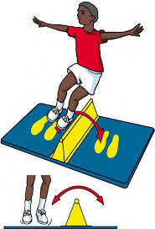
School Games Virtual Challenges
Challenge: Speed Bounce
When: Monday 1st Feb – Sunday 7th January
How many bounces can you do in 30 seconds?
A bouncer develops core stability, balance, agility, and rhythm. These vital skills will improve leg speed and ability to accelerate.
- Place something flat on the floor that you could jump over e.g., a rolled-up towel
- The bouncer must jump with two feet side to side over the line.
- The bouncer has 30 seconds to complete as many bounces as they can.

The winners will be:
- Most bounces for each year group
- School which bounced the most!
Send your results to spatching@ramseyacademy.com before Monday 8th Feb including:
Name:
School:
Gender:
Year Group:
Bounces Achieved:

