The Chief Medical Officer recommends that young people should be physically active for at least 60 minutes every day. The guidelines also suggest that children and young people should aim to minimise the amount of time spent being sedentary - which is quite difficult during a lockdown! Below are some ideas to help keep you active this week.
Look at the 'Keep Essex Active' YouTube channel.
There are a wide variety of exercise sessions for the whole family.

Can you challenge yourself to complete one today?

MONDAY
#ThisIsPE

Can you be king or queen of the cones?

https://www.youtube.com/watch?v=GXN9cYj6eX8&list=PLYGRaluWWTojV3An2WEgsQ4qGFy_91jDL&index=10&t=22s

WEDNESDAY
It is National Cricket Week! Check out this game ‘Last batter stands’ and have a go. There are loads more to try.

https://www.youtube.com/watch?v=cUQKaOQK76w

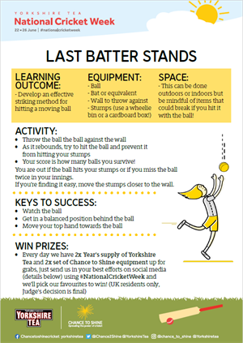

THURSDAY
There are so many fun athletic based games and drills on this channel. Can you do one jumping, one throwing and one running activity?
https://www.youtube.com/channel/UCIIvWCjutNqP4ZSY2FSEQVw/featured

FRIDAY
There are some fantastic resources here if you are learning to ride a bike and great activities if you have already learnt how to do it.
https://readysetride.co.uk/
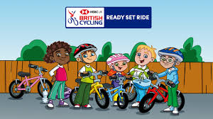

Share your ideas on twitter @NWEssexSSP

sunday
Cosmic Kids Yoga

Enjoy story time and a session from Cosmic Kids Yoga…

https://www.youtube.com/user/CosmicKidsYoga

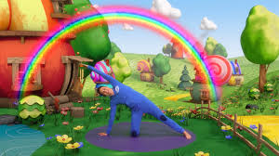
SATURDAY

Can you walk, run or cycle for 30-60 minutes?

Walking is such an easy way to get our 60 minutes a day!

tuesday

