Star of the Week
Ryan Crouch
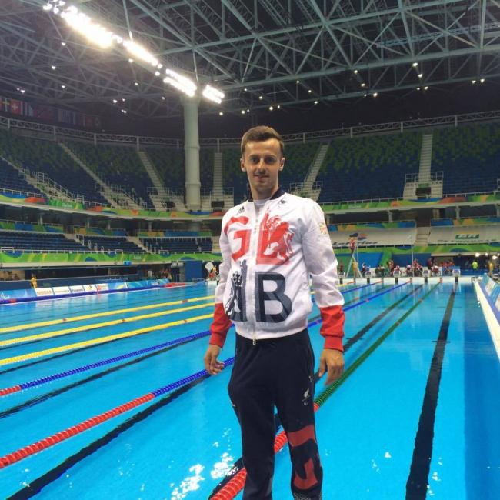

Ryan Crouch is an S9 swimmer with Cerebral Palsy and at the age of 22 years-old, he made it to the 2016 Paralympic Games in Rio. Crouch has been swimming since he was five years old and started racing for Dovercourt Swimming Club in Essex when he was 11 years old. It has not always been a smooth road to success for Crouch due to health setbacks however due to his determination, he has continued persevere to achieve his goals.

Research Challenge: What training have Olympic swimmers been doing during lockdown?
Physical Challenge: Crouch can swim 50m in 27 seconds. How far can you run in 27 seconds?

Creative Challenge: What four swimming strokes are there? Can you write instructions describing how to perform them ?

Ball Challenges
There are many different types of balls used in sports. See if you have the skills needed for the challenges below.
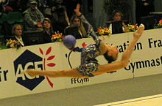
Rhythmic Gymnastics Ball Challenges

Rhythmic Gymnasts are incredibly skilful at travelling, balancing, jumping, and moving with a ball. They sometimes roll the ball along the floor, perform a series of moves and then collect the ball elegantly when they have finished.
Try the challenges below, remembering that gymnasts travel elegantly, lightly and extend the toes and arms whenever possible.

KS1 Routine (You may need to practise many times to make your routine smooth and controlled)
1.Bounce and catch your ball twice.
2.Turn around slowly on your tip toes holding the ball high in the air.
3.Do two jumps whilst holding your ball in one or two hands.
4.Roll your ball in a straight line slowly away from you. Now follow your ball by side stepping quickly with pointed toes. Get ahead of the ball and smoothly kneel to pick it up as it comes towards you. (the trick is to roll the ball very, very slowly)
5. Perform a balance whilst holding onto your ball with one or both hands outstretched.
If you do not have a ball, then you can still do the routine. Perform the actions as though you have a ball in your hands and perform them elegantly and with control.
Lower KS2 Routine
1.Throw the ball in the air, clap and catch the ball twice.
2.Take the ball around your waist passing it from one hand to the other, turning slowly as you do it.
3.Perform 8 light skips in a straight line with pointed toes, holding the ball above your head with straight arms.
4.Throw the ball up in the air and do a star jump before collecting it. (The ball can bounce before you collect it)
5. Perform a balance on one leg and extend your arms balancing the ball in the palm of one hand. You can decide how you extend your arms (above you, in front of you, to the side, asymmetrically or symmetrically). Make sure your toes are pointed and your arms straight and still in the balance.
Add any of your own movements to link the five actions together smoothly, so that your routine looks fluent and controlled. If you do not have a ball, then you can still do the routine. Perform the actions as though you have a ball in your hands and perform them elegantly.

Upper KS2 Routine
1.Stand in a star shape, with your legs and arms out to the sides. Hold the ball in the palm of one hand extended. If the ball is in your right hand, bend the right knee, lunging and throwing the ball above your head to catch it in your left hand. You will need to lunge and bend the left knee as you catch it. If you find it difficult, practise throwing it up higher to give yourself more time to watch the ball and catch it. Repeat throwing the ball back in the opposite direction.
2.From your lunge position jump your feet together and hold the ball out in front with both hands as you step smoothly into a balance on one leg, with pointed toes on extended leg. Hold the balance for 3 seconds.
3. Travel forwards doing 16 elegant skips and holding your arms out to the side, the ball should be in the upturned palm of one hand.
4. Perform a straight jump taking the ball above your head holding it in both hands.
5. Jump your legs apart into a straddle. Take the ball slowly above your head in both hands and slowly touch the ball down on the ground in front of you.
6. With the ball resting on the floor gently push it forwards slowly. As the ball rolls can you run past the ball, do a leap in the air, land straddle your legs. Look back through your legs and let the ball roll through them so you can pick it up.
7. Choose a finishing action to end your routine.
You can add any of your own movements to link the actions together smoothly, so that your routine looks fluent and controlled. If you do not have a ball, then you can still do the routine. Perform the actions as though you have a ball in your hands and perform them elegantly.

Differentiation:
Space – travel in different pathways, change the level or direction of your travel
Task – make your actions easier or harder. Use one hand when catching, do a more difficult balance, make your ball trick easier. Put the routine to music.
Equipment – try doing the actions with different types of balls or use a cushion or another soft object if you don’t have a ball.
People – teach someone else your routine and perform at the same time but at a safe distance apart.

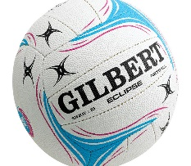
Netball Challenges
This Photo by Unknown Author is licensed under CC BY-SA-NC
To play netball well, you need to be able to control the ball in many ways. Netballers spend many hours practising throwing, catching and aiming skills so they are able to perform well in a game.
KS1 Skill Challenges
1.Catching a bouncing ball. Try catching it at the top of the bounce. Send the ball downwards towards the floor with both hands. Wait till the ball hits the floor, comes back up towards you and then catch it and pull it in to your body, just before it goes back down. Try not to bend down towards the ball, let it bounce back up to you. Practise this again and again until you can always catch the ball at the top of the bounce.
2. Travelling. In netball we must travel quickly in different directions to get away from other players and to get into a good space for someone to give us the ball. You need to be on your toes so you can change direction quickly. Set up a little course that is in a zig zag pathway.
x x x

X x x
Carrying your ball under your arm, run around the markers quickly. Now sidestep around the markers quickly. Run and leap over the markers quickly. Now run and jump with two feet over the markers. Find other ways can you travel over the markers. The more you practise the quicker you will get.
3 Aiming skills. In netball you have to pass the ball accurately to other players. Put a chalk mark on the ground, or throw down a maker (tea towel). Take two steps away from your target and see if you can bounce the ball onto the marker. If you are successful, take another step back. How many steps back can you get ?
Lower KS2 Skill Challenges
- Landing with a ball. In netball when we have the ball in our hands we can spin and pivot on one foot, but not run with the ball. Can you hold the ball in two hands, jump and land on two feet? Now go up onto your toes and keep one foot on the ground whilst you pivot and turn pushing yourself round with your other leg. This is a very tricky skill and will need lots of practice. Run, jump, pivot in and around your area. Try and alternate the foot you pivot on.
- Travelling quickly and being able to get away from your opponent in netball is important. Play “lose your marker” with another player. Stand 2m opposite a partner facing them and place a marker 5 steps to your left and 5 steps to your right. The aim of the game is for Player A to outwit player B by dodging and weaving along their line and getting to their marker before Player 2. Start on your toes and begin when Player A starts to move. Player B is shadowing them, staying level with them, but always staying 2m away. Change over after a set number.
X Player A x
(Lunging and dodging to get away from Player B and get to a marker)

x Player B x
(mirroring and trying to stay level with Player A)
- Creative Aiming skills. In netball you need to be able to pass the balls in many ways. Sometimes you need a short pass and other times a longer one. Set a marker on the floor and find ways of sending the ball so it lands on the marker. Try using different throws to hit the target. A chest pass could be used, holding the ball in two hands, and getting it to land on the marker. Try a one-handed shoulder pass, or an underarm pass. Make up your own target game, being nearer and further away from the target.
Upper KS2 Skill Challenges
- Travel and Land with a ball. In netball when we have the ball in our hands, we have to have at least one foot in contact with the floor, so we can pivot on one foot, but not run with the ball. Hold the ball in two hands, run, then throw the ball up in front of you and catch it, land on one or both feet. Now go up onto your toes and keep one foot on the ground whilst you pivot and turn pushing yourself round with your other leg. This is a very tricky skill and will need lots of practice. Run, throw, land, and pivot in and around your area. Try and alternate the foot you pivot on.
- Throw and collect. Netball players should be able to pass the ball in a variety of ways and be able to collect a ball travelling away from them. For this exercise you need to be able to throw and to travel quickly. Place a target 6- 8 steps away. Do a chest pass, holding the ball in two hands, keep the elbows in and push your hands out in front of you and try and get the ball to land on the target . Run forwards and collect the ball, pivot, and turn to face the target and chest push it back again. How many times do you hit the target in 10 tries? Now play again and see if you can beat your score.
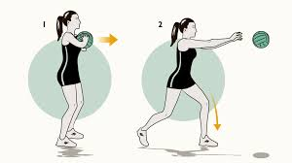
- Shooting target If you play in the position of Goal shooter or Goal Attack, you are the players who score the goals. In netball you hold the ball high above your head and shoot the ball up and above the net, for it to drop down into the net. This practice will help you to learn to shoot high and accurately. It will take a lot of practice to be successful. You do not need a goal just a target on the floor.
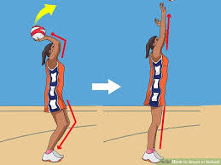
Stand with ball held high above head. Ball sits in the fingers of one hand and with the other hand supporting.
Bend your knees and elbows, keeping your hands high and focus on an imaginary post coming straight up from your marker on the ground.
Extend your knees and elbows and flick the ball off your fingers, push the ball high to allow it to fall into the imaginary net and drop onto your target.
End the shot with your arms high and hands following the ball.
Have 20 shots, using the correct shooting technique. How many times does the ball land on the target?
Play again and try to improve your score. Play against another player, but make sure you have your own ball and target and stay 2m apart.

Rugby Challenges
To be a good Rugby player you need speed and agility. Having good footwork skills are vital to be successful. This is a skill which transfers over into lots of other sports so even if you have never played rugby before give these challenges a go.
KS1 Challenges
1 - Time for Tries - Using any ball or a rolled up pair of socks, set up a straight line course 5 m long. You have 1 minuet to score as many tries as you can. Remember to score a try in Rugby you need to touch the ball on the ground on or behind the try line. It’s a really good idea to carry the ball in both hands so try to do this as your running with the ball.

2- Zig Zag to Score – Mark a zig zag course as shown below you can use tea towels, jumpers anything to mark out your course. The challenge is the sam as above. Run through the zig zags and score a try , run back through the middle and start again , you have 1 minuet to score as many tries as possible.

Lower KS2 Challenge
1 – Side to Side – Set out a marker 2m each side of you and a try line 5m in front (see below). The challenge is to side step touch the ball on one marker then side step to the other marker, go back to the middle and sprint forward as fast as you can to score a try. See how many you can do in 1 min.

2 - Bounce and Score – Rugby players need to be athletic and need powerful legs. This challenge includes power and speed.
With a 5m track and a marker at each end do 10 speed bounces over the first marker then spring to the other end and score a try. Keep repeating until the 1min time limit runs out.
Upper KS2 Challenges
1- Cross step - mark out a 5m course with one end being your try line and at the starting mark make a cross with markers or rolled up tea towels (see below). Starting with one foot each side at the back of the cross you need to step forward into the front half of the cross and back again, then sprint to the try line and score the try, keep repeating for 1 min to see how many tries you can score.
2- Flamingo bounce – With the same 5m track have a marker/rolled jumper at the starting point. Stand on one leg hop over the marker from side to side 5 times sprint and score your try, then return and swap standing legs. Keep going for 1 min and see how many tries you can score.

Cricket Challenges
Cricket is all about either hitting or sending a ball and being accurate as well as quick. Try out each of the tasks below there is a batting and throwing activity for each Key Stage group.
KS1 Challenges
Aiming- This is a simple aiming game, you need something to throw a ball/rolled up socks/toilet roll will work fine. You also need a target a box or bucket would work perfectly. Stand 3 big steps away from the target. You have 5 attempts to see how many times you can underarm through your ball at the target.
Hitting- You need a ball for this practice any light ball that will roll along the ground will work, and something to work as a bat, a tennis racket, book or even a lid to a Tupperware box could do the job.
Set out a target gate 3m in front of you and put the ball on the floor just in front of you. You have 5 attempts to hit the ball through the gate. You can adjust the size of gate or distance from the gate to make it easier or harder.

Lower KS2 Challenges
Aiming 2 - You need an object to throw at a target which could be a box or bucket. Standing 5m away can you overarm throw and hit the target, remember to get sideways on and point at the target with your non-throwing arm. You can make these easier or harder by increasing or decreasing the distance between you and the target or by changing the size of the target.
Hitting 2 - You need a ball or rolled up pair of socks. You also need something to work as a bat if you don’t have a bat, racket a book would do just fine. The challenge is to do as many ball taps as you can in 1min, if the ball drops to the floor that’s fine just pick it up and carry on counting.

Upper KS2 Challenges
Aiming 3 - You need an object to throw at a target which could be a box or bucket. Standing 5m away can you overarm bowl the ball/socks at your target. Remember to overarm bowl you need to straighten your arm as it comes over your head and keep it straight. You can make these easier or harder by increasing or decreasing the distance between you and the target or by changing the size of the target. See the image below to help you with how to bowl.

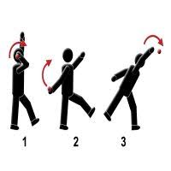

Hitting 3 - You need a ball or rolled up pair of socks. You also need something to work as a bat if you don’t have a bat, racket a book would do just fine. You need lots of space so the school playing field or a local park would work best.
Challenge 1- Can you set yourself to hit the ball as far as you can. You could try and throw the ball up for your self to hit or if you are with a family member ask them to throw the ball for you. See how far you hit it and then try and beat your best distance.
Challenge 2 – Set yourself a target a good distance away and see how few hits of the ball you can make it in.

Top Tip – Hitting a ball a long way isn’t all about strength and force if you time the ball and hit it with a smooth action it will travel a long way .

Volleyball Challenges
To be a good volleyball player you need excellent hand-eye co-ordination as well as really good foot movement.
KS1 Challenges
Balloon tapper – For this game you need a balloon and a little space.
Challenge 1 – Using your writing hand how many balloon taps can you do before the balloon touches the floor.
Challenge 2 – Using your other hand how many balloon taps can you do before the balloon touches the floor.
Challenge 3 – Using alternate hands Right then Left how many balloon taps can you do before the balloon touches the floor.
Challenge 4 – using any part of your body, hands, arms, knees, feet, shoulders etc how many balloon taps can you do before the balloon touches the floor.

Lower KS2 Challenges
Set Challenge – For this practice you need a ball or balloon a football or basketball would be fine.
The challenge is to see how many set shots you can do without the ball/balloon touching the ground. To perform a set shot you must spread your fingers wide and make a triangle pattern with your thumbs and index fingers (see image 1 below). As the ball lands on your fingers you need to have bent elbows and be looking through the triangle (see image 2). Then push the ball up to complete the set shot (see image 3).
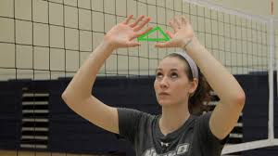

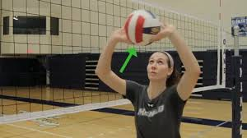

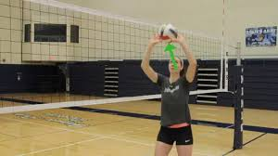

Upper KS2 Challenge
Dig Challenge- For this practice you need a ball or balloon a light plastic football would be fine.
The challenge is to see how many dig shots you can do without the ball/balloon touching the ground. To perform a ‘dig’ you need to get your hands in the right position which is shown in the image below, you are trying to hit the ball on the outside of your thumb area.

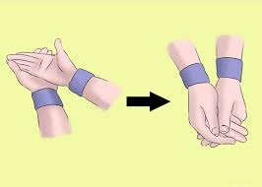

It’s important to get in a low balanced position with your arms out in front of you. As the ball makes contact with your wrist straighten your legs to push the ball back up and not your arms as this will send the ball behind your head and make it really tricky to do a rally. See the image below from USA Volleyball on how to perform a dig.

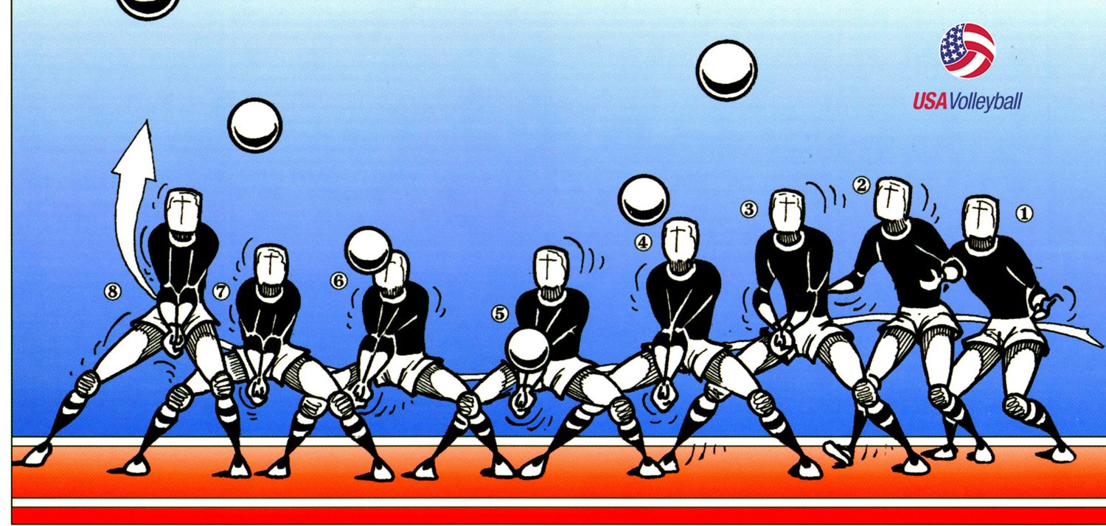

Serve Challenge - For this practice you need a ball a light plastic football would be fine.
This challenge is looking at accuracy. There are two ways to serve a volleyball:
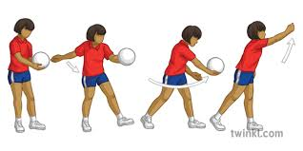
Underarm : see image below

Overarm: see image below
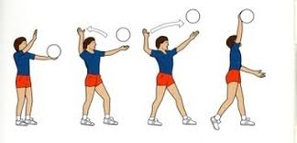

Set yourself a target starting at 5m and see how many serves it takes you to hit the target. You can change how difficult this is by changing the distance between you and the target or by making the target bigger or smaller.

