Week 4
Each week we are going to give you a few ideas to keep both your body and mind active. We will also give you links to online resources we think you may find useful. Each activity will have a KS1 or KS2 option, but feel free to try all the activities if you feel it is appropriate.

Boccia
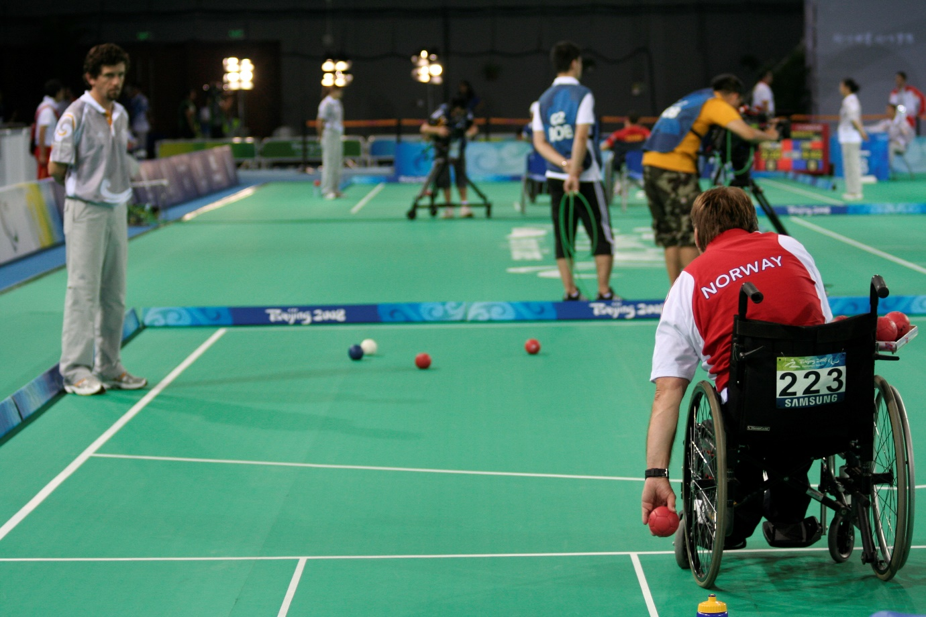
Boccia (pronounced bot-cha) is a Paralympic sport with no Olympic equivalent and is like bowls. The term boccia derives from the Italian word meaning "bowl" and on the continent bowls is often referred to as Bocce.
Boccia has roots in ancient Greece and Egypt and is thought to be one of the first games played by mankind. It is thought that during these times, large stones would have been thrown.
Boccia was originally designed for people with Cerebral Palsy but is now played by people with a wide range of disabilities. In 1984 boccia was introduced into the Paralympics. During these games 19 athletes, representing 5 countries, competed. Nowadays over 50 countries play boccia, making it the fastest growing disability sport in the world.
To find out more go to: https://www.bocciaengland.org.uk/what-is-boccia
Boccia England are holding a virtual competition, please see all the information in the attached resources.
The Paralympic Games
Athletes with physical disabilities compete in these games and are called Paralympians. This includes athletes with mobility disabilities, amputations, blindness, and Cerebral Palsy. There are Winter and Summer Paralympic Games. They are held just after the Olympic Games.

Challenges
1. What is Goal Ball? Who plays it?
2. Sitting Volleyball is a Paralympic sport, how many players in a team?
3. What events take place in the winter Olympics

KS1
Have a go at the Boccia colouring sheets.
KS2
Can you complete the Paralympics wordsearch?

#DailyMileAtHome
Lots of Primary School children in North West Essex are used to completing ‘The Daily Mile’ during the school day. Have a look at www.thedailymile.co.uk for lots of ideas about how to complete your daily mile at home with lots of challenges to make it lots of fun.
Check out this week’s challenges, which is in the resources attached.

Fitness Challenge
Can you turn these activities into a competition to get everyone involved in your house?
Shuttle Runs
Set yourself a straight-line track wherever it is safe to do so. You have 1 minute to complete as many shuttle runs as possible.

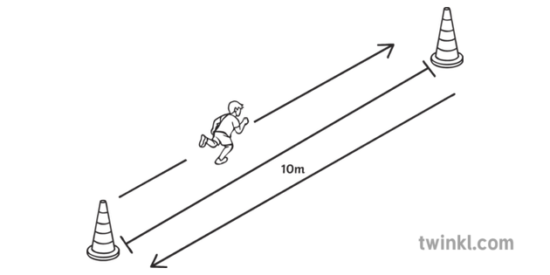
Maths challenge
Measure how far your track is and then work out how far you ran in your 1 min of activity

Next steps
Think of different ways you travel across your track. Remember make sure you keep safe.

Speed bounces
You have 20 seconds to do as many speed bounces as you can. They must be 2 footed jumps from side to side. (like skiing action) KS1 – Can jump over a line on the floor KS2 – Can create a barrier to jump over. (Cushion, jumper?)

Skills Challenge
Ball Taps
This week’s skills challenge is all about improving hand eye co-ordination. Below are the progressions - please feel free to adapt any of the equipment you need/have.

KS1
Using two hands can you throw and catch a ball/Balloon/rolled up pair of socks using two hands. See how many you can do before you drop it.
Challenge
Can you now try with one hand?

KS2
Can you use a bat/racket to do as many taps as possible? You can use two hands on the bat.

Next Steps
Use just one hand on the bat/racket and see how many taps you can do. By the end of the week see how many you can do without the ball hitting the ground.

Orienteering Challenge
KS1
Cross the River resource attached.
KS2
Save the Treasure resource attached.

Active Essex
How amazing is the Active Essex YouTube channel? If you didn’t get a chance to have a go, really try this week. Search ‘Keep Essex Active’ on YouTube and you will find a whole timetable to activity ideas to keep all the family busy this week.
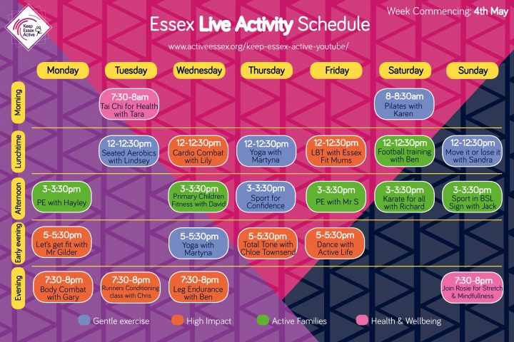

Chance to Shine Cricket

If you go to the website below there are a variety of lesson plans available to support cricket coaching, including explanation videos and top tips from the pros, which you can follow from home. There are also cricket-themed literacy and numeracy lessons.
https://www.chancetoshine.org/staying-active-during-the-covid-19-outbreak

Tabletop Cricket
This looks like a great game created by the Chelmsford SSP…
This week’s skills challenge is about accuracy and concentration. We have created a game that can be done inside on a kitchen/dining room table.
The image below shows how we set up our game.
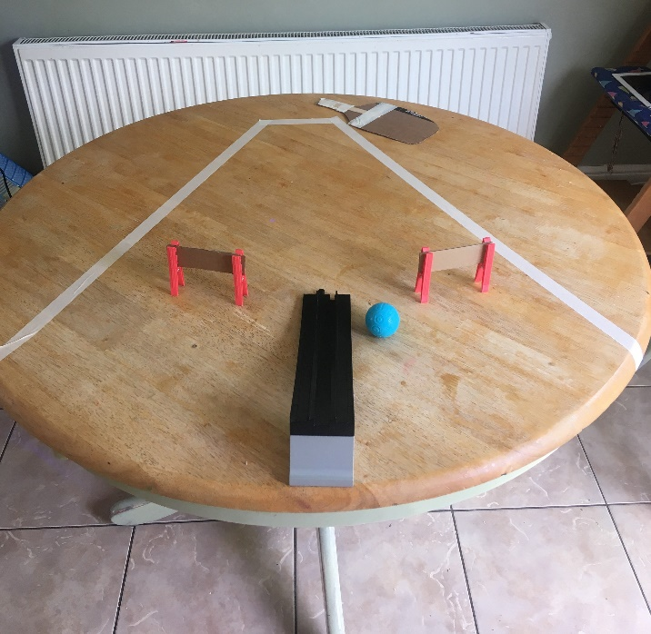
Batting Crease

Out of Bounds Line

Gates

Bowlers Ramp

Rules
- Batsman stands at the end where the batting crease is
- Bowler stands at the end of the ramp
- The bowler rolls the ball down the ramp towards the batsman.
- The batsman must wait for the ball to get to the crease before hitting the ball, we made a carboard bat reinforced with lollypop sticks, but you can use your palm or flick with your finger.

Scoring
- a ball hit through a gate scores 2 runs
- A ball hit over the edge of the table in without crossing the out of bounds line scores 4
- A ball that goes out of bounds does not score.
- Each batsman faces 1 over (6 deliveries) then they swap over.

Challenge
Can you adapt the game to make it harder? Could the gates be fielders? Could the bowler be allowed to catch the ball if it comes off the table and score runs for catching it?

