Football’s Staying Home
Each week we are going to give you a few ideas to keep both your body and mind active. We will also give you links to online resources we think you may find useful.

Last term we had been doing lots of work in schools to encourage girls to play football and to make sure they had lots of opportunities to play inside and outside of school if they wanted to.
There are some resources attached in which you can design your own football and your own football team – have a go and please get a grown up to send your pictures to me on twitter @NWEssexSSP

KS1
Once you have finished your colouring can you find out how many players are in a football team?

KS2
Can you think of 5 rules that we must follow when playing football?

If you can, why not play some football in your garden? There are also lots of ideas of other football related activities for you to try at home at:
http://www.thefa.com/get-involved/footballs-staying-home

Active Essex
How amazing is this activity schedule from Active Essex? These sessions are all taking place on their YouTube channel (link below) and is sure to keep us all active and feeling good.
Could you try and do at least two of these sessions this week? It is so exciting to try new activities, and this will be a great opportunity for you to check out some new ways to exercise. I am really looking forward to doing some karate on Saturday as I have never done it before!

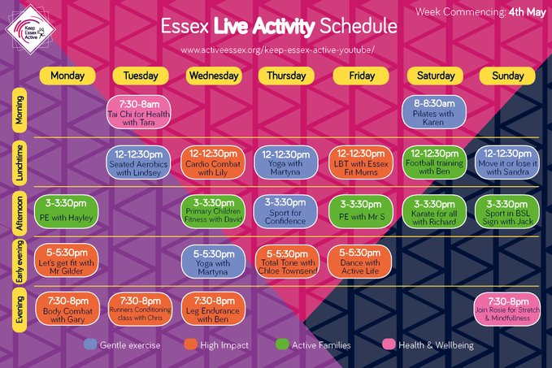

Gymnastic Activities
Have a look at the gymnastics resources in the ‘parent zone’ for week 3 and have a go at home. There is also a video demonstration for each one.
Balance time https://www.youtube.com/watch?v=jscbqUkVpVo&list=PLnwoPgo24bhmqV8Y76iXnwYw9T9AlxbqJ&index=3&t=0s

Jumping Dice
https://www.youtube.com/watch?v=ufTx2tiT_VQ&list=PLnwoPgo24bhmqV8Y76iXnwYw9T9AlxbqJ&index=25&t=0s

Sequence Champions
https://www.youtube.com/watch?v=sIElQTPVc3Q&list=PLnwoPgo24bhmqV8Y76iXnwYw9T9AlxbqJ&index=15&t=0s

Change 4 Life
Another website I am finding useful with my children is the NHS ‘Change 4 Life’ page. It offers lots of easy ways to help us and our children to eat well and move more. There are so many activity ideas for inside and outside and lots of them are Disney inspired. Pick at least one of the activities/games/recipes to try this week.
https://www.nhs.uk/change4life

