The London Marathon – Week 2
Each week we are going to give you a few ideas to keep both your body and mind active. We will also give you links to online resources we think you may find useful. Each activity will have a KS1 or KS2 option, but feel free to try all the activities if you feel it is appropriate.
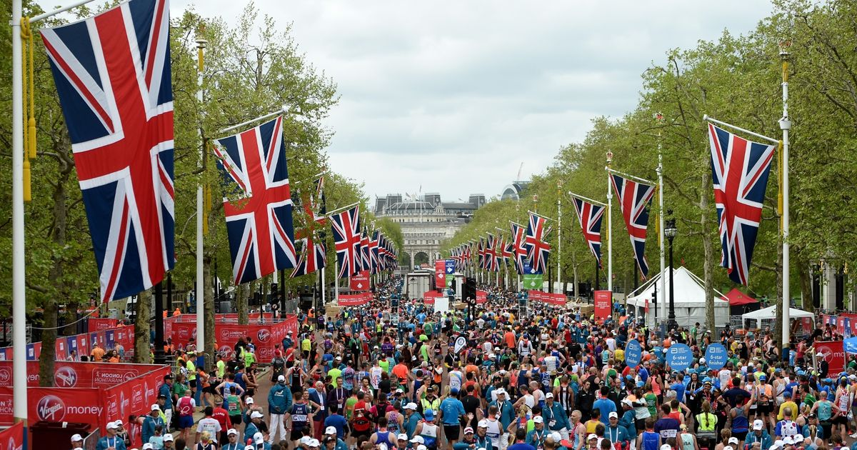
Last weekend was meant to be the London Marathon but unfortunately it had to be cancelled.

KS1
Have a look at the KS1 marathon presentation – do you like running?
Have a go at some of the KS1 colouring sheets.

KS2
Have a look at the KS2 marathon presentation and answer the following questions:
How far is the London Marathon?
What was the warmest and coolest temperature for the London Marathon race day?
Why do people run the London Marathon?

Who has run the marathon the fastest for each race? There’s a men’s race, a women’s race a wheelchair race for men and a wheelchair race for women.
Would you like to run a marathon when you are grown up?

Family Marathon Challenge
Attached in the resources below is a ‘Marathon Mileage Log’ – can your family collectively complete a marathon over the next few weeks?! You do not have to run, you can walk. You can track your distances ¼ of a mile at a time. I have been doing this with my family and we have walked 22 miles so far…we are nearly there!

Creative Task
KS1
Turn on some music or watch videos of your favourite songs and dance with everyone you live with. If you get tired, stop the music, rest, then turn the music back on and repeat until warm.
If you like Disney, try these…
https://www.thisgirlcan.co.uk/activities/disney-workouts/

KS2
Create and choregraph a dance using the worksheet ‘KS2 Choreograph a dance’ to help you start.

Fitness
KS1 and KS2
Circuit
Why not create a family fitness circuit using the ‘Circuit cards’ and ‘Healthy Heart Circuit’ worksheets? This can be done inside or outside. Putting on some music whilst you exercise can help to keep you moving.

Family Challenge
Just like last week - look the resources named ‘Tap Up Tennis Challenge’, ‘Jump Squat Challenge’ and ‘Super Slalom Run Challenge’. Have a family competition! Children – make a chart to record everyone’s results. Maybe everyone could get more than one attempt to try to achieve their best performance. What could a reward be for the winning family member? Please tweet me at @NWEssexSSP – I would love to see how you all get on!

Bingo
Why not have a game of Physical Activity Bingo – worksheet attached below.

Active Learning
Why not be active and learn at the same time! Could you adapt any of these activities for other topics your teachers have asked you to learn at home?

KS1
Look at the ‘Active Learning Phonics Hopscotch’ worksheet.

KS2
Look at the ‘Active Learning Times Tables Squats’ worksheet.

Things to try this week…

Glen Higgins Fitness brings you superhero workouts to Get Kids Moving.
https://www.youtube.com/channel/UCokO71NW3TgndaSNyHIqwtQ

Personal challenge videos – why not have a go at some of these yourself…
https://www.youtube.com/playlist?list=PLX9GnyQdxaf5SqSnTYy_pc51k7lIPi4je

